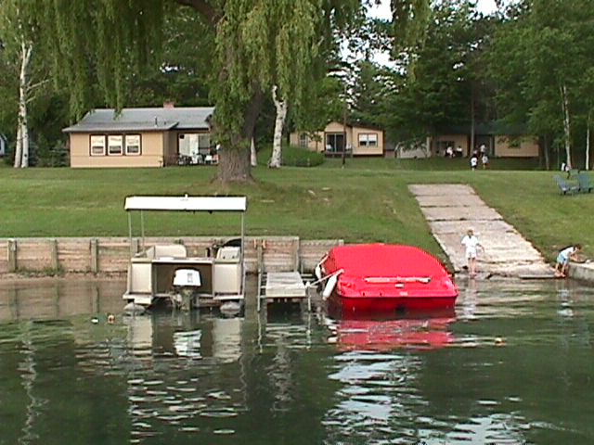

Cottage’s 1, 2, and 3 have 3 Bedrooms
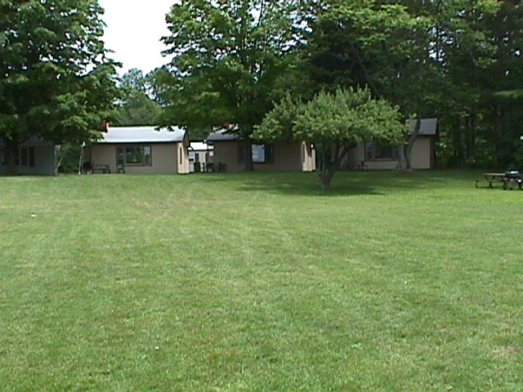
Cottage 6 is 1 Bdrm, & Unit 7 is 2 Bedroom
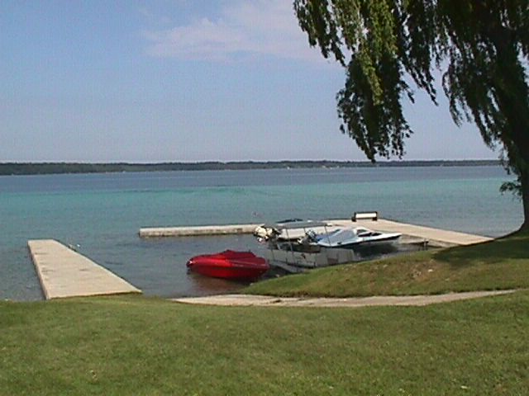
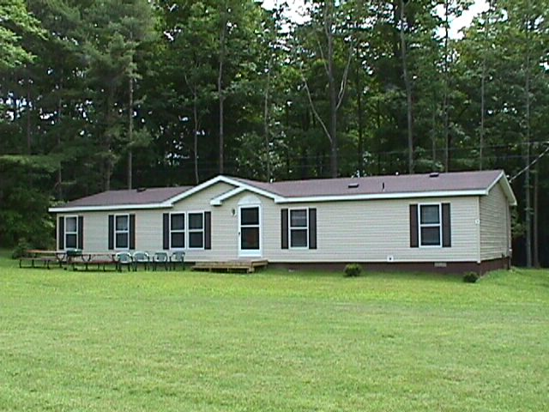
Cottage 4 has 4 Bedrooms
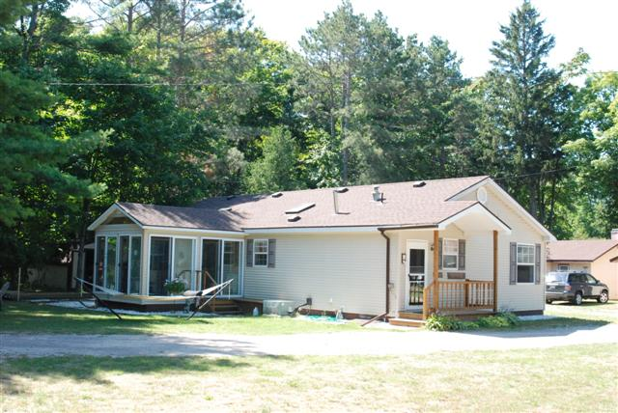
Cottage 8 is fully equipped with all conveniences of home. 3 Bdr & 2 bth. Available to rent all year long.
Torch Lake

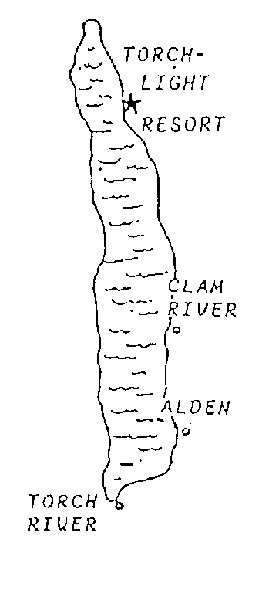

“Where The
Rainbow
Stores
It’s Colors”

Length 19 mi.
Shoreline 42 mi.
Avg. Width 1.65 mi.
Max. Width 2.85 mi.
Depth 297 ft.

Say Yes to Michigan!

American Historic Inns
Michigan Vacation Guides
Travel Michigan
Torchlight
Resort



Cottages

Resort Living
on Beautiful

“Torch Lake”

One of the World’s
Most Beautiful Lakes
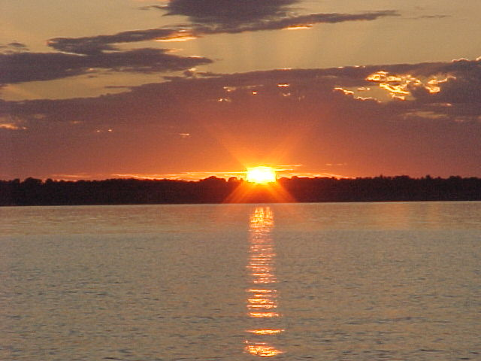

Part of
Antrim County
Chain of Lakes

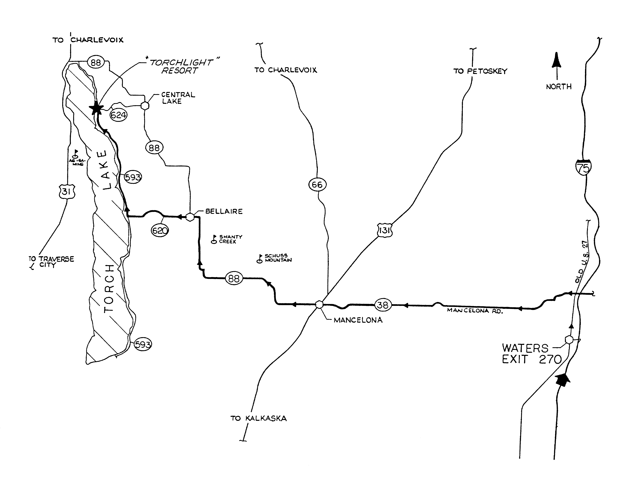
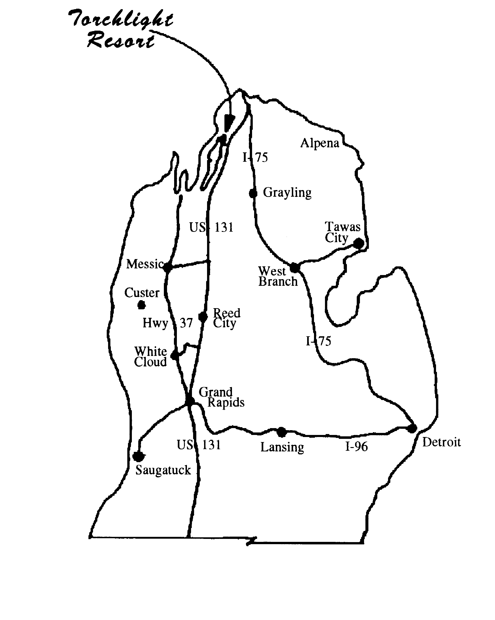

Torchlight Resort
Co. Rd. 593, East Torch Lake Drive
3 Miles West of Central Lake, MI.

COTTAGES
4 Bedroom Unit Sleeps 12
3 Bedroom Units Sleeps 6
2 Bedroom Unit Sleeps 5-6
1 Bedroom Unit Sleeps 4
FOR RESERVATIONS:
Torchlight Resort
Central Lake, MI 49622
www.TorchlakeCA.com
Click on the renter page and select the unit you are interested in renting. There are 8 units total which are all individually owned and operated. Your web site request will be sent to the appropriate owners.

Our Torchlight Resort is located on the northeast part of Torch Lake, 1/4 mile south of Co. Rd. 624 or 6 1/2 miles north of Co. Rd. 620, on E. Torch Lake Dr.

Torch Lake is part of the Antrim County Chain of Lakes. The lower chain, 40 miles of navigable water, includes Lake Bellaire, Clam Lake, Torch Lake, Lake Skegemog, and Elk Lake. The upper chain, above the dam, has nine more lakes with 21 miles of navigable water. There are many sheltered bays and quiet coves for enjoyable fishing for the avid angler and family boating.

There are Northern Pike, Jumbo Perch, Bass, Brown Trout, Muskie, Steelhead, Salmon, Whitefish, and a variety of pan fish. Charter fishing is available on Torch Lake and Grand Traverse Bay.

The area offers some of the most beautiful scenery in Michigan, fine restaurants, excellent golfing and is centrally located to Traverse City, Charlevoix, Boyne City and Petoskey.

There are 1, 3 and 4 bedroom cottages which are clean and comfortable. They are carpeted and all have showers. All cottages are modern with hot and cold water, gas ranges, gas heating, electric refrigerators, microwaves, TV/VCR/DVD combo and barbeque grills. All cooking utensils and dishes are furnished.

••NO PETS ALLOWED••
• Linens and towels are not furnished in cottages.
• A non-refundable deposit is required on all
cottages to hold reservation.
• A week starts on Saturday at 1:00 p.m. until the
following Saturday at 9:00 a.m. This allows us only
4 hours for preparing for the next renter. Your cooperation is appreciated.
• Watercraft dockage and trailer storage available.
• Clean and Safe swimming area.

